Digital Signal Processing
(EECE 5510)

Project-1 Report
Submitted by – Mohammad Saber
(MUID: 005852837)
Table of Contents
Part-1 2
a) Filter Design and Implementation: 2
Design: 2
Analysis: 4
b) Filter Application: 6
Part-2: 8
a)MATLAB Demonstration: 8
b)Run Demo: 8
c)Additional Image processing demo (ipexnormxcorr2) 9
Part-3: 10
Introduction 10
Sound effects 11
Frequency band filtering/equlization 11
Reverberation 13
Tremolo (amplitude modulation effect) 14
Vibrato (frequency modulation effect) 15
chorus 17
Tunnelecho 19
flanging (tempo effect) 20
slapback 22
Reference 23
Appendix 24
User Manual 24
Code for sound effect Generation: 27

Part-1

a) Filter Design and Implementation:
For first part of this project, I have designed a band pass filter and analyze its performance.

Design:
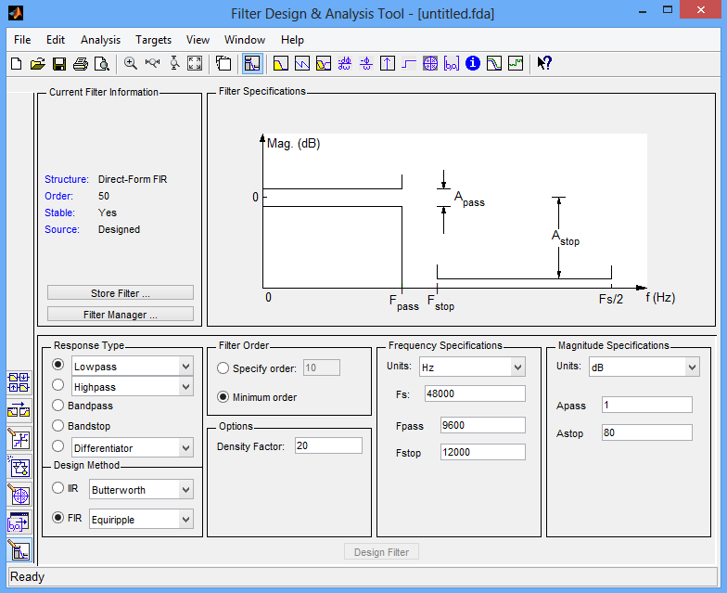
I have opened sptool from MATLAB to design the required filter. Then I clicked on ‘new’ button from sptool to open fdatool. The following figure shows when I opened fdatool.

Figure 1.1: fdatool of MATLAB
Then I have given the following specification to design my filter and press on “Design Filter” button to design my required filter.
Response Type: Bandpass
Design Method: IIR (Elliptic)
Filter Order: Minimum Order
Frequency Specification:
    - Fs: 44100
    - Fstop1: 1300
    - Fpass1: 1500
    - Fpass2: 2500
    - Fstop2: 2700
Magnitude Specification:
    - Units: dB
    - Astop1: 50
    - Apass : 1
    - Astop2: 50
Figure-1.2 shows my designed filter according to above configuration. The filter design and analysis file (fda) has been included in the project deliverables under Part_1_Filter directory as Filter_saber.fda. This file can be opened and viewed using the fdatool.
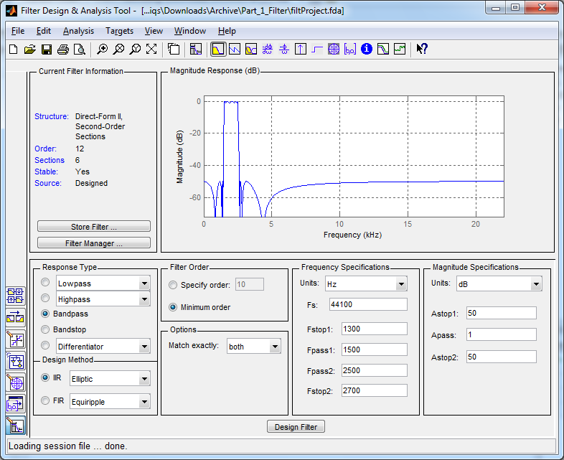
Figure1.2: Designed filter

Analysis:
Once I have exported the Filters using Export menu and got two variables named SOS and G in workspace. I have used the following commands to analyze the filter:
[b,a] = sos2tf(SOS,G);
fvtool(b,a)
Figure-1.3 has been generated after executing above commands.
Magnitude Response:
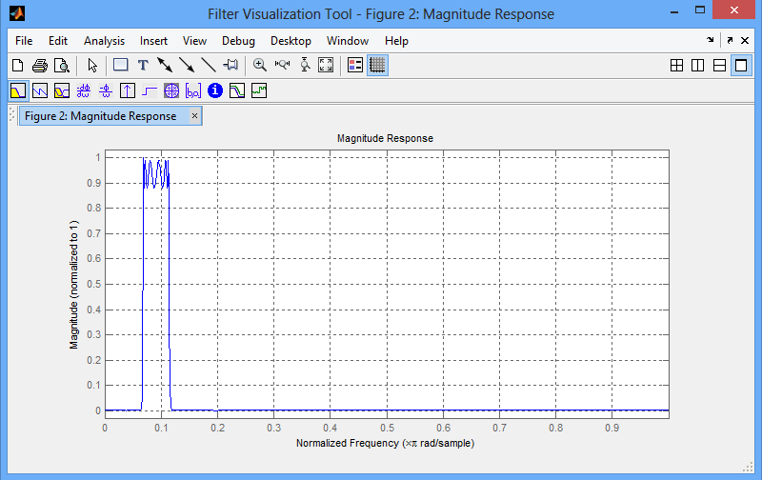
Figure 1.3: Magnitude Response
The filter’s magnitude response showing a bandpass behavior between 0.068*pi and 0.1134*pi which perfectly make scenes since the 2*pi corresponds to sampling frequency 44100.
So, Start Pass (at 1500 Hz) = 2*pi*1500/44100 = 0.068*pi
And End Pass (at 2500 Hz) = 2*pi*2500/44100 = 01134*pi

Phase Response:
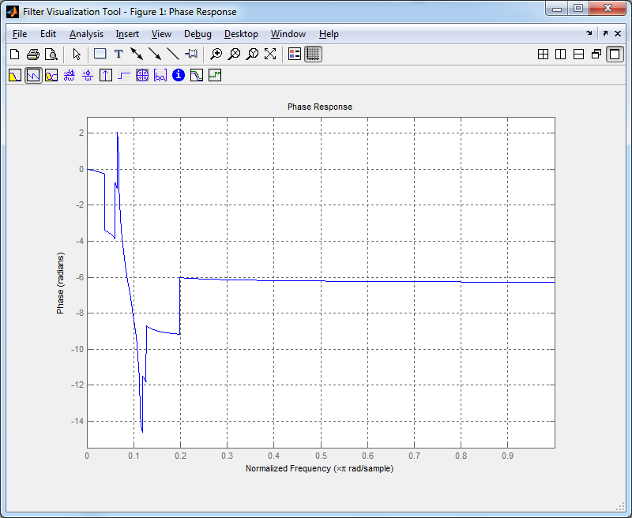
Figure 1.4: Phase Response
The phase shows variations between 0 and 0.2*pi, whereas it shows almost linear behavior after 0.2*pi.
Impulse Response:
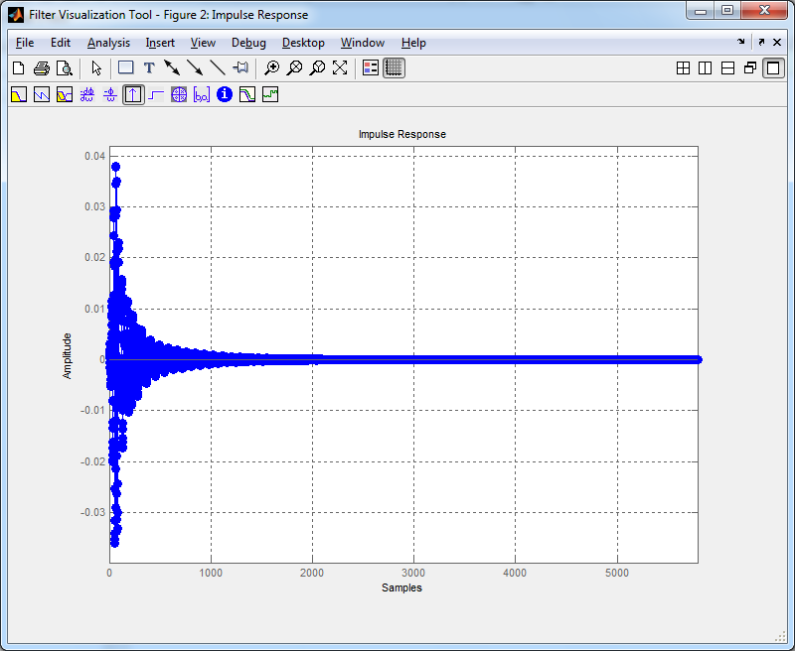
Figure 1.5: Impulse Response
The impulse response shows an exponential behavior. The responses are high for initial delays whereas the values die down and become almost zero for the later delay terms.
Pole Zero Diagrams:
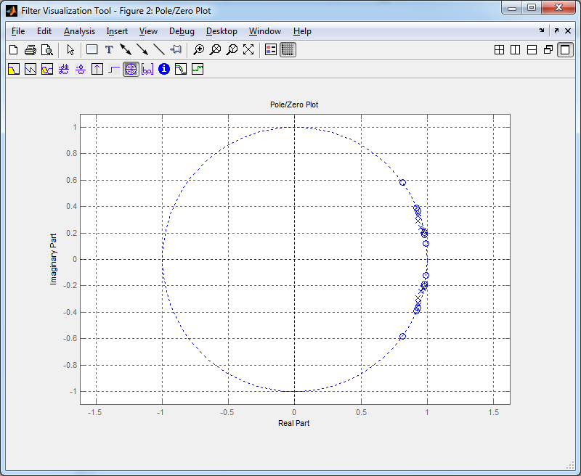
Figure 1.6: Pole Zero Diagram
It is found that, almost all poles/zeros are on (or very near to) the unit circle. All poles and zeroes are imaginary and it seems they are appeared to be in conjugate pairs. The polses and zero setup clearly explain the bandpass behavior somewhere near to 0.1*pi.

b) Filter Application:
In order to test the filter I have exported them to the workspace and got two variable SOS and G. I have taken a wav file Sample Cannon_Flute.wav which is inside the directory Part_1_Filter and read the file using wavread.
x = wavread('Cannon_Flute.wav');
plot(abs(fft(x)))
I have plotted the graph for x and for it frequency characteristics (Figute 1.7). Apparantly, the sound mostly have low frequency components (expcted as it is mainly flute sound). I have passed the signal through the filter using the command sosfilt.
y = sosfilt(SOS,x);
plot(abs(fft(y)))

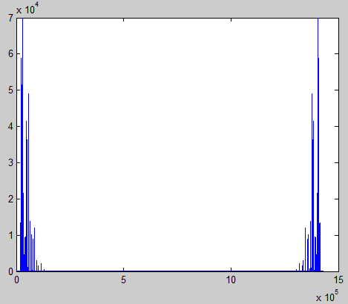
I have also plotted the graph for output signal y and its frequency characteristics (Figure 1.8). From the out put signal, it is apparent that, some of the components are filtered. The frequency spectrum of the output signal clearly demonstrates the filtering application on it.
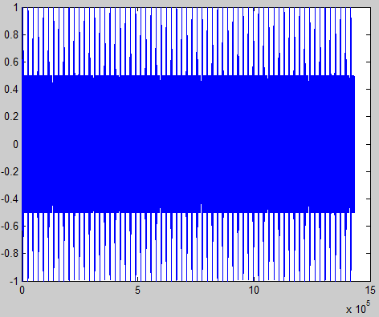
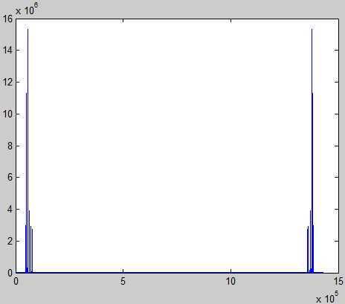
Figure 1.7: a) Input Signal b) Input Frequency Spectrum
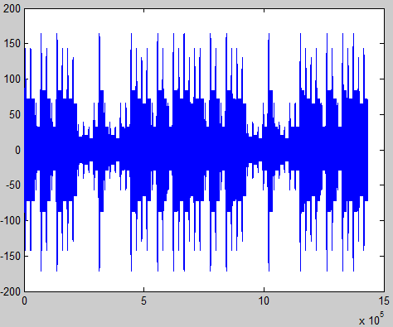
Figure 1.8: a) Output Signal b) Output Frequency Spectrum
The axis for the Frequency Spectrum is not normalized (it should be considered as from 0 to 2*pi). So, the two bars shown in the output frequency show the bandpass behavior of the filtered signal, they are symmetric across the 0 if we consider the axis from –pi to pi. Hence, it can be concluded that, the filter performing as expected. I have also listened to the original and output sounds and the output sound is distorted with some metallic effect on it.

Part-2:

a)MATLAB Demonstration:
I have executed “help sigdemos” in MATLAB and list of signal processing demos appeared. I have chosen filterguitardemo, though I like music.

b)Run Demo:
This demo implemented the Karplus-Strong Algorithm for generating guitar sounds. The main idea is to implement a discrete time filer which can generate sound wave with the harmonics similar to the one when the guitar is plucked. Generally, there are six strings in a guitar (A, E, D, G, B, and E2).
The demo is performing several different tasks within it. At first, it prepares a discrete time filer for playing a single note on an open string (it's an A string). The filter is generated by considering the poles to be representing the harmonics of A string and zeroes are for frequency shaping. The filter is initiated with non-rest (zero) state with persistence memory. This allows having a non-zero response even when the input signal is a series of zeroes. Magnitude response for the filter is shown in below (left) figure. Output is generated by applying the filter to an input signal containing series of zeroes. The output sounds like an open A string.
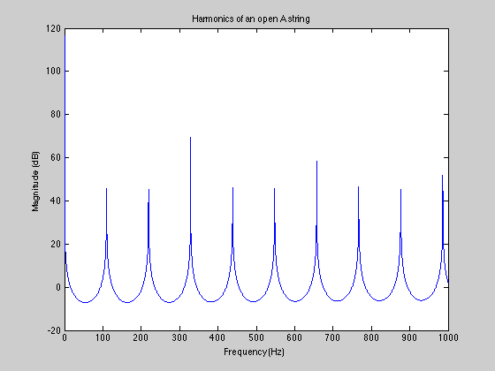
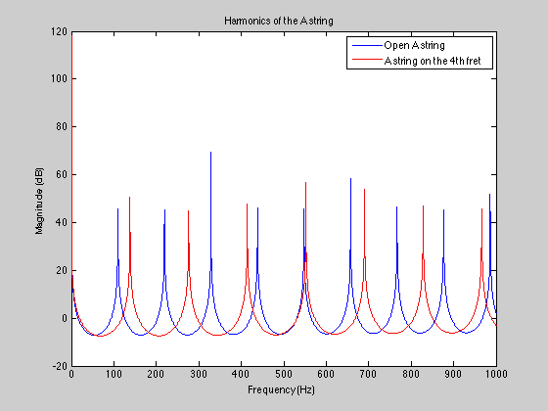
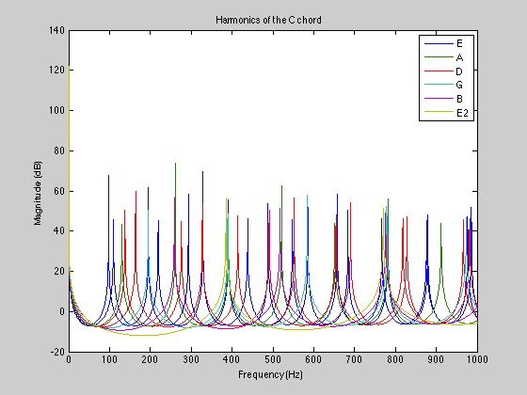
Figure 2.1: a) Open A string b) Fretted A String c) C Chord
In the next part, a fretted string is being played. The main logic for playing a fretted string is to calculate the delay based on the fret number (generally, it’s from 0 to 11). For the fret value r, the string frequency is multiplied by 2^(r/12) and the revised frequency is used for calculating the delay. This is the only difference for the fretted string techniques. However, the magnitude response for the filter is changed (shown above, middle).
The next part in the Demo shows how to play a specific chord (c chord). The main idea is to play different strings with different fret values and combine them together. For example for C chord the fret values should be 3 3 2 0 1 3. These fret values added with the different offset values for different string and used for calculating the revised delays (there will be six of them). Six different filters are generated with these six delays. The magnitude response of those filters is shown above (right). These filters are applied to the same input signal and the output are summed together and played.
The final section shows how to add the summing effect by adding 50 milliseconds offset between each note. This has been done by just padding necessary zeroes in front.

c)Additional Image processing demo (ipexnormxcorr2)
Purpose of this image processing demo is to find out normalized cross-correlation between two images in order to find out the way to register or align one of the images through translation. The demo read two images and does necessary processing as following:
Choose sub-region for those two images in a way so that say are related. The demo uses imgcrop function to select the sub region.
The next section uses normxcorr2 function to find out the normalized cross-correlation. The demo displays the plot which in fact shows the similarity between the two sub-images. The cross-correlation is peak where the similarity is the maximum (below left).
Figure 2.2: a) normalized cross-correlation plot, b) Padded image c) Image Overlay
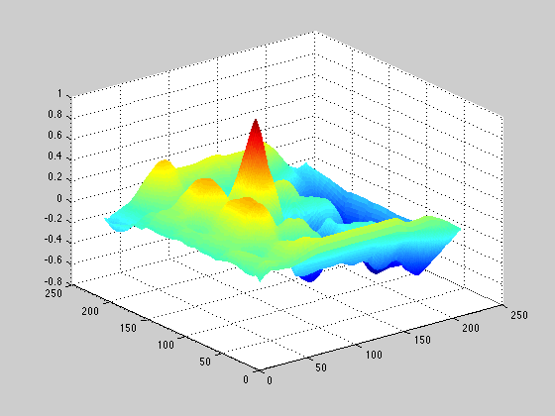
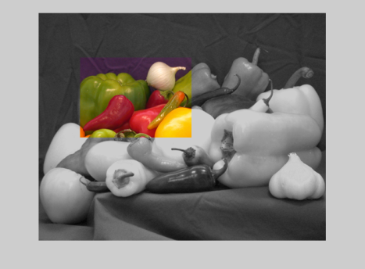
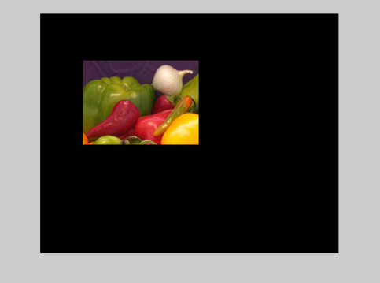
After this, the offset of the translation between two images are calculated based on the size and position of the sub-images, which is the correlative offset. Then the relative offset are calculated based on the position. Then the total offset is calculated by adding the correlative offset and the relative offset.
Next step checks if the onion image is a part of the pepper image. This is being done by extracting the image from pepper with the same size of the onion image.
The demo then used the offset to determine the padding size for the onion image. The image is padded such that it become as the same size as the pepper image (above middle).
Make the onion image semitransparent by applying the mask (0.2 values for area other than onion, and 1 for onion region). Then overlay the images and the final image is produced (above right).

Part-3:

Introduction
As part of this project I have to implement some sound effects and design a GUI in MATLAB to run those sound effects to demonstrate all sound effect. At first I have decided to create a GUI in MATLAB [2,3,4]. When you run this GUI application, it will look like figure 3.1
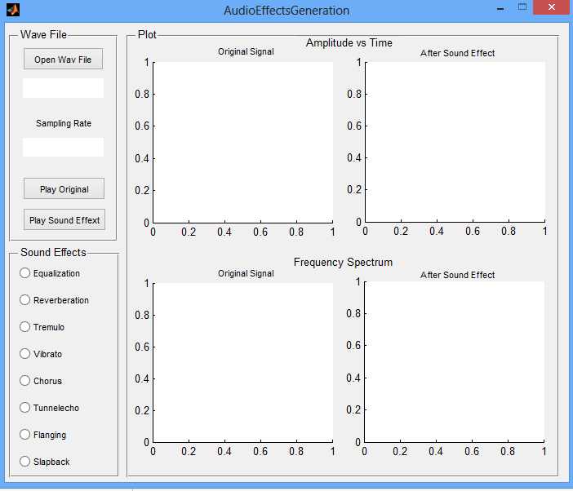
Figure 3.1: Sound effect generation GUI
In GUI there are three panels. From first panel, user can browse a wav file from computer. After selecting a wav file, the file name and sampling frequency of this wav file will be displayed on the screen. Then user can play the file pressing ‘Play Original’ button which also displays the graph of the signal in plot panel. Another panel contains 8 sound effects selection option. At a time user can select only one audio effect. Whenever user select a audio effect from sound effect panel then the particular audio sound will play and corresponding graph of the audio effect will show in the plot panel.

Sound effects
I have tried to implement following sound effects:
- Frequency band filtering/equalization
- Reverberation
- Tremolo (amplitude modulation effect)
- Vibrato (frequency modulation effect)
- Chorus
- Tunnelecho
- Flanging (tempo effect)
- Slapback
I have explored some other sound effects but exclude from report due to time shortage. I have recorded all eight sound effects (all output sound effect files are 5 sec long) for an original signal and provide it inside ‘Part_3_Sound_Effect\Test run recording for sound effect’ folder. There are some other sample signals available inside ‘Part_3_Sound_Effect\Sample WAV Files’ folder for testing the GUI.

Frequency band filtering/equlization
Music equalizers are commonly used to adjust the amplitudes of the frequency components of audio signals. To get equalization effect we can divide the original signal to pass through some band pass filters with different gains and later add them up to get processed signal like figure 3.2. One low pass and seven band pass IIR filters with specific cut-off frequencies and different gains are used to design the equalizer, as shown in table 1.
Filter | Lower Cut-off frequency (Hz) | Upper Cut-off frequency (Hz) | Gain
Low Pass IIR | 200 | N/A | 6
Band Pass IIR | 200 | 500 | 3
Band Pass IIR | 500 | 1,000 | 2
Band Pass IIR | 1,000 | 2,000 | 1.7
Band Pass IIR | 2,000 | 4,000 | 1.3
Band Pass IIR | 4,000 | 7,000 | 1
Band Pass IIR | 7,000 | 12,000 | 0.8
Band Pass IIR | 12,000 | 20,000 | 0.6
Table 1: List of all filters used for the implementation of the Equalizer Effect
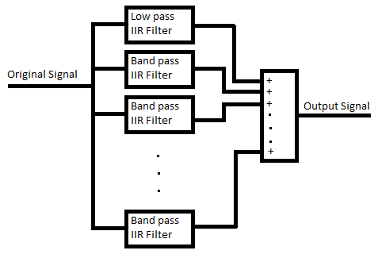

Figure 3.2: Equalizer design model
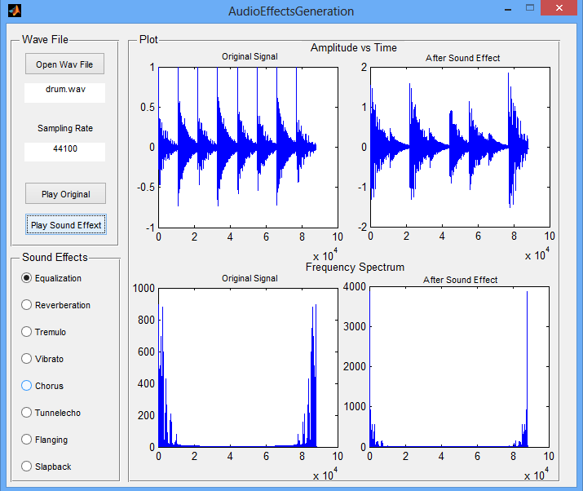
Figure 3.3: Plot and GUI for equalization sound effect

Figure 3.3 shows the plot of original signal and equalization sound effect using MATLAB GUI.

Reverberation
Reverberation is used to simulate the reflections of sound from the walls in a large auditorium. The following difference equation is used generate reverberation sound effect.

Here, x[n] is the input signal and y[n] refers to the output signal. I have used 60ms delay and 0.7 gain to implement reverberation sound effect. Figure 3.4 illustrates the reverberation model used in this project which is self-explanatory. Figure 3.5 shows the plot of original signal and reverberation sound effect using MATLAB GUI.

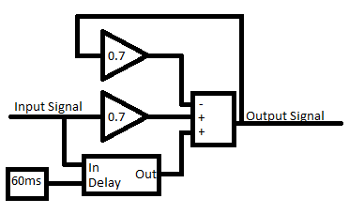

Figure 3.4: Reverberation design model
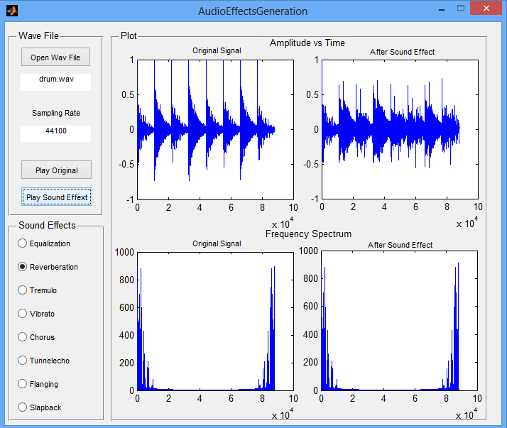
Figure 3.5: Plot and GUI for reverberation sound effect

Tremolo (amplitude modulation effect)
Tremolo is an amplitude modulation effect, which was implemented by modulating the input audio signal with a 5 Hz sine wave. The carrier wave should be less than 15Hz to generate trembling sound effect. Figure 3.6 shows a model for generating tremolo sound effect.
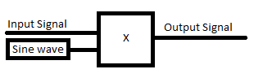

Figure 3.6: Tremolo design model
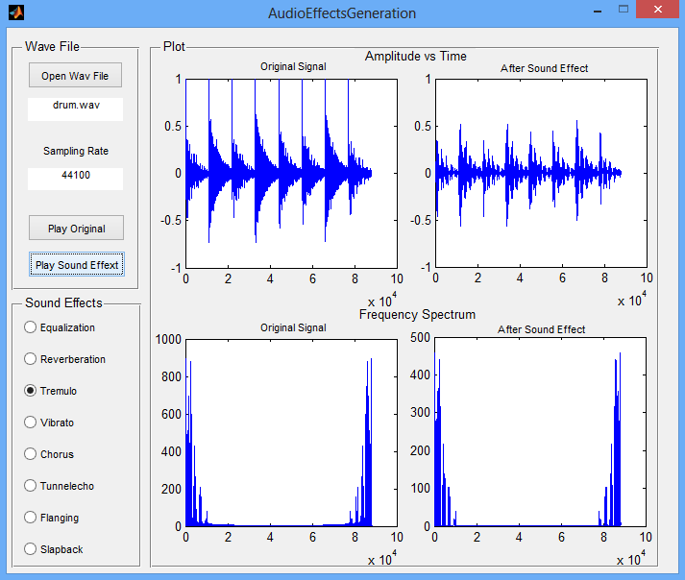
Figure 3.7: Plot and GUI for tremolo sound effect

Figure 3.7 shows the plot of original signal and tremolo sound effect using MATLAB GUI.

Vibrato (frequency modulation effect)
Periodically varying time delay, we can produce a vibrato sound effect. We need a delay line and a low frequency oscillator (LFO) to implement the vibrato audio effect. Typical delay time and LFO rate to design a vibrato are 5-10ms and 5-14Hz respectively. I used 8ms delay and 10Hz LFO rate to design a vibrato sound effect for this project. Figure 3.8 shows a model for generating vibrato sound effect.

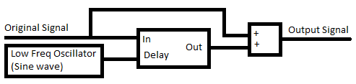

Figure 3.8: Vibrato design model

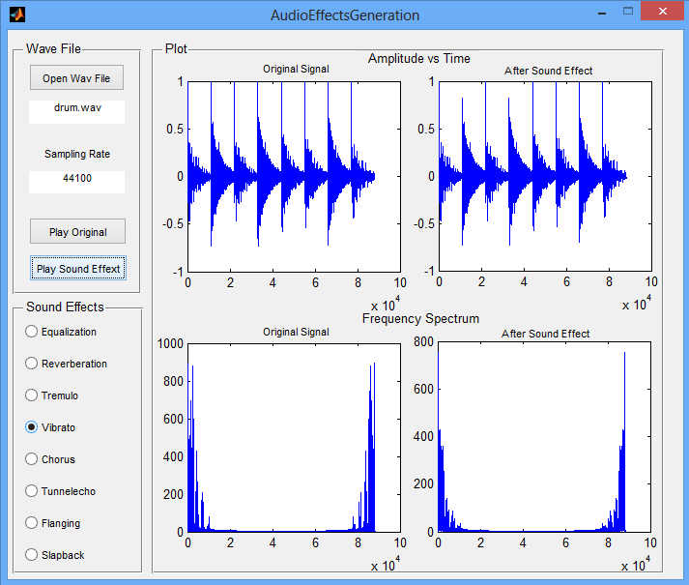
Figure 3.9: Plot and GUI for vibrato sound effect

Figure 3.9 shows the plot of original signal and vibrato sound effect using MATLAB GUI.

chorus
Chorus is a time-based delay effect which has been implemented by adding five copies of the original signal, each delayed by a random time delay between 10ms and 25ms. The signals were then added together to form the output audio signal. Figure 3.10 illustrates design model for implementing chorus sound effect. Figure 3.11 shows the plot of original signal and chorus sound effect using MATLAB GUI. We observe that from the plot, amplitude of all individual copies of the signal is not modulated.

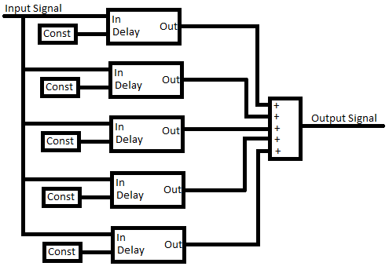

Figure 3.10: Chorus design model
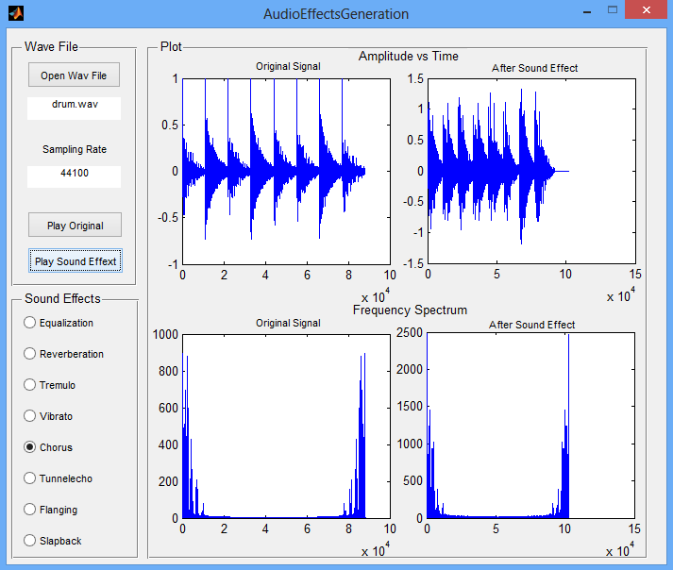
Figure 3.11: Plot and GUI for chorus sound effect

Tunnelecho
Tunnelecho is a time-based delay effect, which has been implemented by the addition of ten copies of the original signal, each delayed by a time of 250ms. This audio effect lasts for a much longer duration than original signal. The amplitude of each copy of the original signal was decayed linearly until it was almost mute for the last echo. Figure 3.12 illustrates design model for implementing tunnelecho sound effect. Figure 3.13 shows the plot of original signal and tunnelecho sound effect using MATLAB GUI.

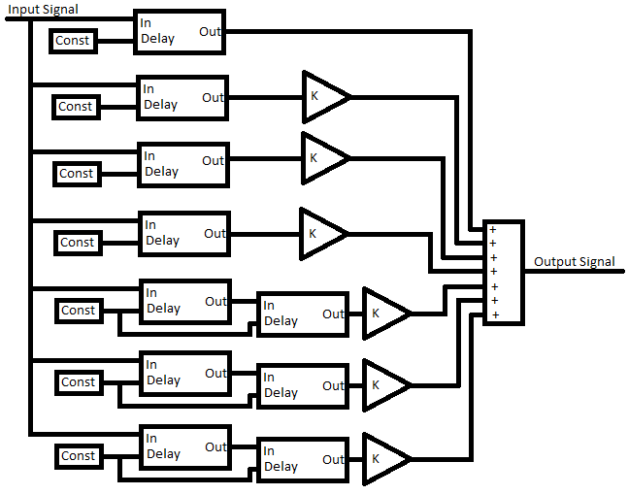
Figure 3.12: Tunnelecho design model

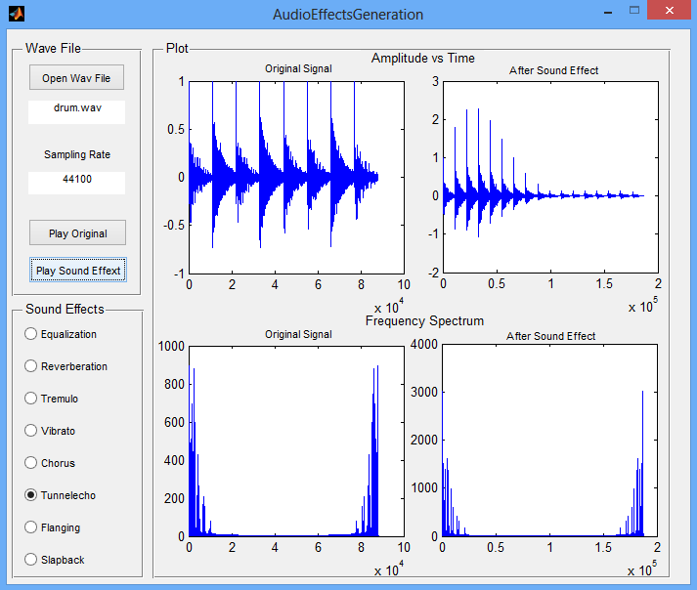
Figure 3.13: Plot and GUI for tunnelecho sound effect

flanging (tempo effect)
We can generate flanging sound effect by varying delay time. In this project we varied the delay time between 0 and 3 milliseconds using 1Hz sinusoidal wave. Therefore output signal will be a continuous delay of input signal is a continuously varying delayed version of the input signal. Figure 3.14 shows how it works.

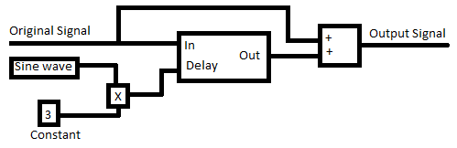

Figure 3.14: Flanging sound effect

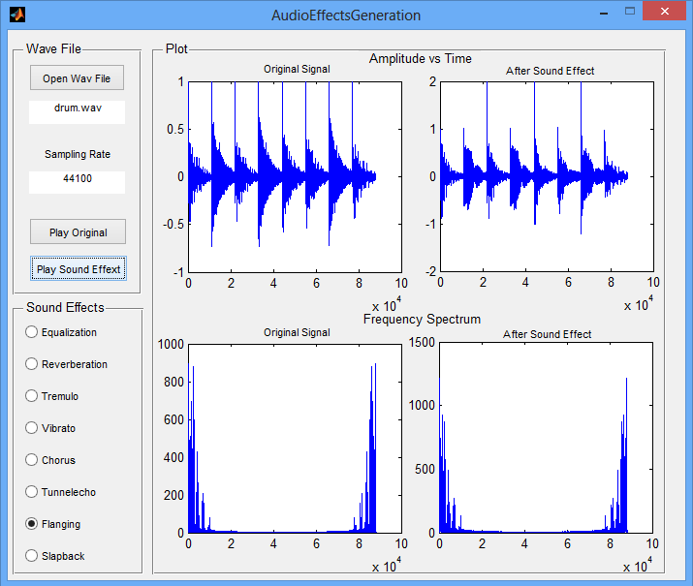
Figure 3.15: Plot and GUI for flanging sound effect

Figure 3.15 shows the plot of original signal and flanging sound effect using MATLAB GUI.

slapback
Slapback is a time-based delay effect, where the input signal is repeated back with a very short delay time of 150 ms. It was implemented in MATLAB by adding the original signal with a delayed copy of itself. Figure 3.16 illustrates slapback design model. In slapback audio effect, the amplitude of the two copies of the input signals remains constant. Figure 3.17 shows the plot of original signal and slapback sound effect using MATLAB GUI.

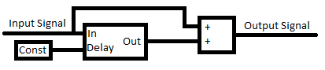

Figure 3.16: Slapback design model
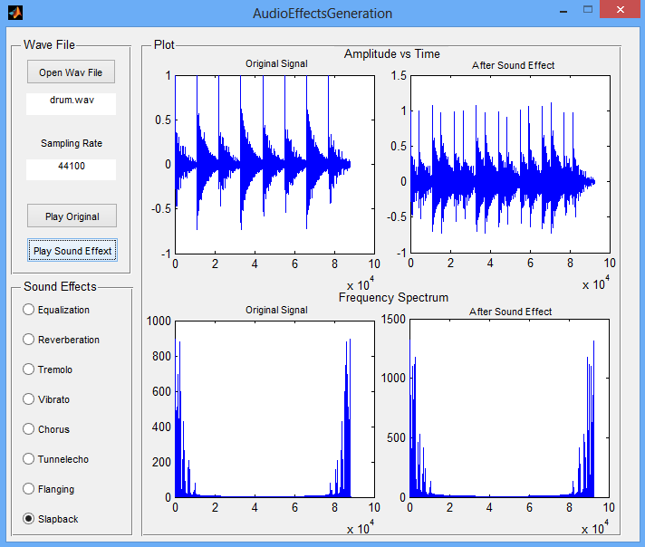
Figure 3.17: Plot and GUI for slapback sound effect

Reference
[1] Sound effect, http://en.wikipedia.org/wiki/Audio_effects
[2] MATLAB Tutorials - Creating GUI, http://www.youtube.com/watch?v=qAGiAq6HhYQ
[3] Open a file by MATLAB GUI, http://www.youtube.com/watch?v=WN2dN3PceSQ
[4] Displaying images in multiple axes, http://www.youtube.com/watch?v=ANAMwGtLgys
[5] MATLAB demonstration – basic signal manipulation using audio signals, http://www.youtube.com/watch?v=ie7iREcYBPU
[6] Modeling reverb in MATLAB, http://cnx.org/content/m14222/latest/
[7] Digital audio effects, http://www.cs.cf.ac.uk/Dave/CM0268/PDF/10_CM0268_Audio_FX.pdf
[8] MATLAB demonstration - basic signal manipulation using audio signals, http://www.youtube.com/watch?v=ie7iREcYBPU
Appendix

User Manual for sound effect generation:
The required m-file to run sound effects is inside ‘Part_3_Sound_Effect’ folder. First make sure MATLAB software is installed in your machine and then double on ‘AudioEffectsGeneration.m’ file. The code window will open with MATLAB codes. If run the code then you will see the following GUI in your screen.
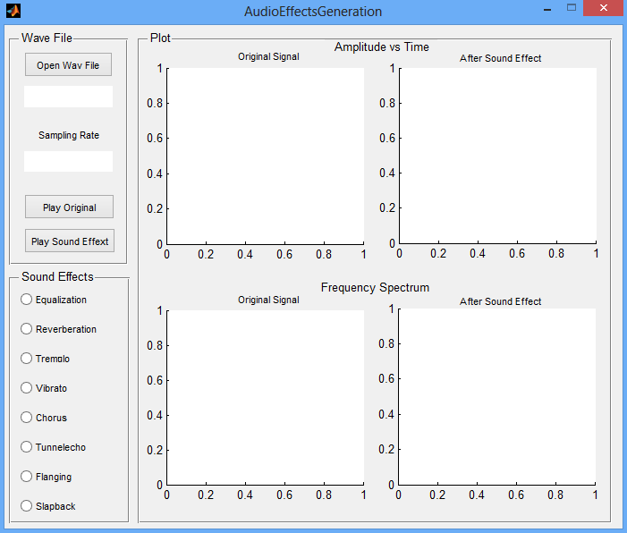
Figure 4.1: MATLAB GUI for audio effect generation
The top left corner of the window, there is a panel called ‘Wave File’. Click on ‘Open Wav File’ button to browse wav file from your computer. There are some sample wav file inside ‘Part_3_Sound_Effect\Sample WAV files’ folder. You can browse and chose any *.wav file from your computer. When you finish selecting wav file the program will show the wav file name and sampling rate of that wav file on the screen like figure 4.2. Then you can click on ‘Play Original’ button for listening to original audio signal. While playing audio signal, the program will automatically generate an amplitude vs time diagram of the selected wav file and its frequency spectrum plot on ‘Plot’ panel.
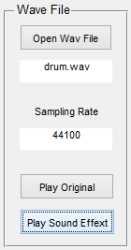
Figure 4.2: ‘Wave File’ panel to select *.wav file and showing file name with sampling rate
Now, we can select our desired sound effect from ‘Sound Effects’ panel by clicking on our desired sound effect from the list. The selected sound effect will be highlighted like figure 4.3 which shows ‘Slapback’ sound effect was selected. You cannot choose two or more sound effects at a time. Program will automatically take care of it if you mistakenly select more than one sound effect at time. After selecting the sound effect then you can press ‘Play Sound Effext’ button to hear your desired sound effect as well as see the graph of modified signal on ‘Plot’ panel.
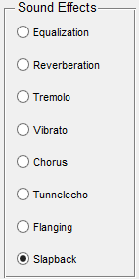
Figure 4.3: ‘Sound Effects’ panel to select sound effect
A typical plot on ‘Plot’ panel of original and sound effect signal are shown in figure 4.4.
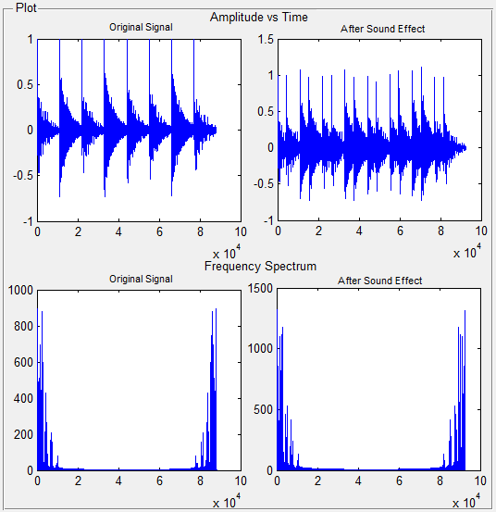
Figure 4.4: ‘Plot’ panel shows amplitude vs time and frequency spectrum of original and modified signal

Code for sound effect Generation:
function varargout = AudioEffectsGeneration(varargin)
% AUDIOEFFECTSGENERATION MATLAB code for AudioEffectsGeneration.fig
% AUDIOEFFECTSGENERATION, by itself, creates a new AUDIOEFFECTSGENERATION or raises the existing
% singleton*.
%
% H = AUDIOEFFECTSGENERATION returns the handle to a new AUDIOEFFECTSGENERATION or the handle to
% the existing singleton*.
%
% AUDIOEFFECTSGENERATION('CALLBACK',hObject,eventData,handles,...) calls the local
% function named CALLBACK in AUDIOEFFECTSGENERATION.M with the given input arguments.
%
% AUDIOEFFECTSGENERATION('Property','Value',...) creates a new AUDIOEFFECTSGENERATION or raises the
% existing singleton*. Starting from the left, property value pairs are
% applied to the GUI before AudioEffectsGeneration_OpeningFcn gets called. An
% unrecognized property name or invalid value makes property application
% stop. All inputs are passed to AudioEffectsGeneration_OpeningFcn via varargin.
%
% *See GUI Options on GUIDE's Tools menu. Choose "GUI allows only one
% instance to run (singleton)".
%
% See also: GUIDE, GUIDATA, GUIHANDLES

% Edit the above text to modify the response to help AudioEffectsGeneration

% Last Modified by GUIDE v2.5 02-Nov-2013 21:17:56

% Begin initialization code - DO NOT EDIT
gui_Singleton = 1;
gui_State = struct('gui_Name', mfilename, ...
'gui_Singleton', gui_Singleton, ...
'gui_OpeningFcn', @AudioEffectsGeneration_OpeningFcn, ...
'gui_OutputFcn', @AudioEffectsGeneration_OutputFcn, ...
'gui_LayoutFcn', [] , ...
'gui_Callback', []);
if nargin && ischar(varargin{1})
gui_State.gui_Callback = str2func(varargin{1});
end

if nargout
[varargout{1:nargout}] = gui_mainfcn(gui_State, varargin{:});
else
gui_mainfcn(gui_State, varargin{:});
end
% End initialization code - DO NOT EDIT

% --- Executes just before AudioEffectsGeneration is made visible.
function AudioEffectsGeneration_OpeningFcn(hObject, eventdata, handles, varargin)
% This function has no output args, see OutputFcn.
% hObject handle to figure
% eventdata reserved - to be defined in a future version of MATLAB
% handles structure with handles and user data (see GUIDATA)
% varargin command line arguments to AudioEffectsGeneration (see VARARGIN)

% Choose default command line output for AudioEffectsGeneration
handles.output = hObject;

% Update handles structure
guidata(hObject, handles);

% UIWAIT makes AudioEffectsGeneration wait for user response (see UIRESUME)
% uiwait(handles.figure1);

% --- Outputs from this function are returned to the command line.
function varargout = AudioEffectsGeneration_OutputFcn(hObject, eventdata, handles)
% varargout cell array for returning output args (see VARARGOUT);
% hObject handle to figure
% eventdata reserved - to be defined in a future version of MATLAB
% handles structure with handles and user data (see GUIDATA)

% Get default command line output from handles structure
varargout{1} = handles.output;

% --- Executes on button press in btnEqualization.
function btnEqualization_Callback(hObject, eventdata, handles)
% hObject handle to btnEqualization (see GCBO)
% eventdata reserved - to be defined in a future version of MATLAB
% handles structure with handles and user data (see GUIDATA)

% Hint: get(hObject,'Value') returns toggle state of btnEqualization
a=get(hObject,'Value')
if(a==1)
set(handles.btnReverberation,'Value',0);
set(handles.btnTremolo,'Value',0);
set(handles.btnVibrato,'Value',0);
set(handles.btnChorus,'Value',0);
set(handles.btnTunnelecho,'Value',0);
set(handles.btnFlanging,'Value',0);
set(handles.btnSlapback,'Value',0);
end

% --- Executes on button press in btnReverberation.
function btnReverberation_Callback(hObject, eventdata, handles)
% hObject handle to btnReverberation (see GCBO)
% eventdata reserved - to be defined in a future version of MATLAB
% handles structure with handles and user data (see GUIDATA)

% Hint: get(hObject,'Value') returns toggle state of btnReverberation
a=get(hObject,'Value')
if(a==1)
set(handles.btnEqualization,'Value',0);
set(handles.btnTremolo,'Value',0);
set(handles.btnVibrato,'Value',0);
set(handles.btnChorus,'Value',0);
set(handles.btnTunnelecho,'Value',0);
set(handles.btnFlanging,'Value',0);
set(handles.btnSlapback,'Value',0);
end

% --- Executes on button press in btnTremolo.
function btnTremolo_Callback(hObject, eventdata, handles)
% hObject handle to btnTremolo (see GCBO)
% eventdata reserved - to be defined in a future version of MATLAB
% handles structure with handles and user data (see GUIDATA)

% Hint: get(hObject,'Value') returns toggle state of btnTremolo
a=get(hObject,'Value')
if(a==1)
set(handles.btnEqualization,'Value',0);
set(handles.btnReverberation,'Value',0);
set(handles.btnVibrato,'Value',0);
set(handles.btnChorus,'Value',0);
set(handles.btnTunnelecho,'Value',0);
set(handles.btnFlanging,'Value',0);
set(handles.btnSlapback,'Value',0);
end

% --- Executes on button press in btnVibrato.
function btnVibrato_Callback(hObject, eventdata, handles)
% hObject handle to btnVibrato (see GCBO)
% eventdata reserved - to be defined in a future version of MATLAB
% handles structure with handles and user data (see GUIDATA)

% Hint: get(hObject,'Value') returns toggle state of btnVibrato
a=get(hObject,'Value')
if(a==1)
set(handles.btnEqualization,'Value',0);
set(handles.btnReverberation,'Value',0);
set(handles.btnTremolo,'Value',0);
set(handles.btnChorus,'Value',0);
set(handles.btnTunnelecho,'Value',0);
set(handles.btnFlanging,'Value',0);
set(handles.btnSlapback,'Value',0);
end

% --- Executes on button press in btnChorus.
function btnChorus_Callback(hObject, eventdata, handles)
% hObject handle to btnChorus (see GCBO)
% eventdata reserved - to be defined in a future version of MATLAB
% handles structure with handles and user data (see GUIDATA)

% Hint: get(hObject,'Value') returns toggle state of btnChorus
a=get(hObject,'Value')
if(a==1)
set(handles.btnEqualization,'Value',0);
set(handles.btnReverberation,'Value',0);
set(handles.btnTremolo,'Value',0);
set(handles.btnVibrato,'Value',0);
set(handles.btnTunnelecho,'Value',0);
set(handles.btnFlanging,'Value',0);
set(handles.btnSlapback,'Value',0);
end

% --- Executes on button press in btnTunnelecho.
function btnTunnelecho_Callback(hObject, eventdata, handles)
% hObject handle to btnTunnelecho (see GCBO)
% eventdata reserved - to be defined in a future version of MATLAB
% handles structure with handles and user data (see GUIDATA)

% Hint: get(hObject,'Value') returns toggle state of btnTunnelecho
a=get(hObject,'Value')
if(a==1)
set(handles.btnEqualization,'Value',0);
set(handles.btnReverberation,'Value',0);
set(handles.btnTremolo,'Value',0);
set(handles.btnVibrato,'Value',0);
set(handles.btnChorus,'Value',0);
set(handles.btnFlanging,'Value',0);
set(handles.btnSlapback,'Value',0);
end

% --- Executes on button press in btnFlanging.
function btnFlanging_Callback(hObject, eventdata, handles)
% hObject handle to btnFlanging (see GCBO)
% eventdata reserved - to be defined in a future version of MATLAB
% handles structure with handles and user data (see GUIDATA)

% Hint: get(hObject,'Value') returns toggle state of btnFlanging
a=get(hObject,'Value')
if(a==1)
set(handles.btnEqualization,'Value',0);
set(handles.btnReverberation,'Value',0);
set(handles.btnTremolo,'Value',0);
set(handles.btnVibrato,'Value',0);
set(handles.btnChorus,'Value',0);
set(handles.btnTunnelecho,'Value',0);
set(handles.btnSlapback,'Value',0);
end

% --- Executes on button press in btnSlapback.
function btnSlapback_Callback(hObject, eventdata, handles)
% hObject handle to btnSlapback (see GCBO)
% eventdata reserved - to be defined in a future version of MATLAB
% handles structure with handles and user data (see GUIDATA)

% Hint: get(hObject,'Value') returns toggle state of btnSlapback
a=get(hObject,'Value')
if(a==1)
set(handles.btnEqualization,'Value',0);
set(handles.btnReverberation,'Value',0);
set(handles.btnTremolo,'Value',0);
set(handles.btnVibrato,'Value',0);
set(handles.btnChorus,'Value',0);
set(handles.btnTunnelecho,'Value',0);
set(handles.btnFlanging,'Value',0);
end

% --- Executes on button press in btnOpenWaveFile.
function btnOpenWaveFile_Callback(hObject, eventdata, handles)
% hObject handle to btnOpenWaveFile (see GCBO)
% eventdata reserved - to be defined in a future version of MATLAB
% handles structure with handles and user data (see GUIDATA)
[filename pathname]= uigetfile({'*.wav'},'File Selector');
pathname=strcat(pathname,filename);
set(handles.txtFileName,'String',filename)
[signal, Fs] = wavread(pathname);
set(handles.txtSamplingRate,'String',Fs)
set(handles.txtPath,'String',pathname)

% --- Executes on button press in btnPlayOriginal.
function btnPlayOriginal_Callback(hObject, eventdata, handles)
% hObject handle to btnPlayOriginal (see GCBO)
% eventdata reserved - to be defined in a future version of MATLAB
% handles structure with handles and user data (see GUIDATA)
x=get(handles.txtPath,'String');
[signal, Fs]=wavread(x);
axes(handles.axsOriginalSignalAT);
plot(signal)
axes(handles.axsOriginalSignalFS);
plot(abs(fft(signal)))
wavplay(signal,Fs)

% --- Executes on button press in btnPlaySoundEffect.
function btnPlaySoundEffect_Callback(hObject, eventdata, handles)
% hObject handle to btnPlaySoundEffect (see GCBO)
% eventdata reserved - to be defined in a future version of MATLAB
% handles structure with handles and user data (see GUIDATA)
if(get(handles.btnEqualization,'Value'))
x=get(handles.txtPath,'String');
[signal, Fs]=wavread(x);
y=equalizer(signal,Fs);
axes(handles.axsSoundEffectAT);
plot(y)
axes(handles.axsSoundEffectFS);
plot(abs(fft(y)))
wavplay(y,Fs)
elseif(get(handles.btnReverberation,'Value'))
x=get(handles.txtPath,'String');
[signal, Fs]=wavread(x);
delay=60;
gain=0.7;
y=reverberation(signal,Fs,gain,delay);
axes(handles.axsSoundEffectAT);
plot(y)
axes(handles.axsSoundEffectFS);
plot(abs(fft(y)))
wavplay(y,Fs)
elseif(get(handles.btnTremolo,'Value'))
x=get(handles.txtPath,'String');
[signal, Fs]=wavread(x);
f=10; % frequency in Hz
y=tremolo(signal,Fs,f);
axes(handles.axsSoundEffectAT);
plot(y)
axes(handles.axsSoundEffectFS);
plot(abs(fft(y)))
wavplay(y,Fs)
elseif(get(handles.btnVibrato,'Value'))
x=get(handles.txtPath,'String');
[signal, Fs]=wavread(x);
Modfreq=10; % 10 KHz
Width=0.0008; % 8 Ms
y=vibrato(signal,Fs,Modfreq,Width);
axes(handles.axsSoundEffectAT);
plot(y)
axes(handles.axsSoundEffectFS);
plot(abs(fft(y)))
wavplay(y,Fs)
elseif(get(handles.btnChorus,'Value'))
x=get(handles.txtPath,'String');
[signal, Fs]=wavread(x);
y=chorus(signal,Fs)
axes(handles.axsSoundEffectAT);
plot(y)
axes(handles.axsSoundEffectFS);
plot(abs(fft(y)))
wavplay(y,Fs)
elseif(get(handles.btnTunnelecho,'Value'))
x=get(handles.txtPath,'String');
[signal, Fs]=wavread(x);
delay=250;
n=10;
y=tunnelecho(signal,Fs,delay,n);
axes(handles.axsSoundEffectAT);
plot(y)
axes(handles.axsSoundEffectFS);
plot(abs(fft(y)))
wavplay(y,Fs)
elseif(get(handles.btnFlanging,'Value'))
x=get(handles.txtPath,'String');
[signal, Fs]=wavread(x);
delay=3;
y=flanging(signal,Fs,delay)
axes(handles.axsSoundEffectAT);
plot(y)
axes(handles.axsSoundEffectFS);
plot(abs(fft(y)))
wavplay(y,Fs)
elseif(get(handles.btnSlapback,'Value'))
x=get(handles.txtPath,'String');
[signal, Fs]=wavread(x);
delay=100;
n=2;
y=slapback(signal,Fs,delay,n);
axes(handles.axsSoundEffectAT);
plot(y)
axes(handles.axsSoundEffectFS);
plot(abs(fft(y)))
wavplay(y,Fs)
end

%Frequency band filtering/ equalizer
function y = equalizer(signal,Fs)
filt_gain = [6 3 2 1.7 1.3 1 0.8 0.6];

[b,a] = butter(2,200/(Fs/2),'low');
y1 = filt_gain(1).*filter(b,a,signal);

[b,a] = butter(2,[(200/(Fs/2)) (500/(Fs/2))],'bandpass');
y2 = filt_gain(2).*filter(b,a,signal);

[b,a] = butter(2,[(500/(Fs/2)) (1000/(Fs/2))],'bandpass');
y3 = filt_gain(3).*filter(b,a,signal);

[b,a] = butter(2,[(1000/(Fs/2)) (2000/(Fs/2))],'bandpass');
y4 = filt_gain(4).*filter(b,a,signal);

[b,a] = butter(2,[(2000/(Fs/2)) (4000/(Fs/2))],'bandpass');
y5 = filt_gain(5).*filter(b,a,signal);

[b,a] = butter(2,[(4000/(Fs/2)) (7000/(Fs/2))],'bandpass');
y6 = filt_gain(6).*filter(b,a,signal);

[b,a] = butter(2,[(7000/(Fs/2)) (12000/(Fs/2))],'bandpass');
y7 = filt_gain(7).*filter(b,a,signal);

[b,a] = butter(2,[(12000/(Fs/2)) (20000/(Fs/2))],'bandpass');
y8 = filt_gain(8).*filter(b,a,signal);

y = y1+y2+y3+y4+y5+y6+y7+y8;

%Reverberation
function y = reverberation(signal, Fs, gain, delay_time)

len=length(signal);

delay = round(Fs*(delay_time/1000));

y = signal;

for i=(delay+1):1:len
y(i,1) = (gain*signal(i,1)) + signal((i - delay),1) - (gain * y((i - delay),1));
end

%Tremolo
function y = tremolo(signal, Fs, freq)
len=length(signal);

t=1:len;
modulator = sin(2*pi*t*freq/Fs);

y = signal.*modulator';

%vibrato
function y=vibrato(signal,Fs,freq,Width)
Delay=Width; % basic delay of input sample in sec
DELAY=round(Delay*Fs); % basic delay in # samples
WIDTH=round(Width*Fs); % modulation width in # samples

f=freq/Fs; % modulation frequency in # samples
len=length(signal); % # of samples in WAV-file
l=2+DELAY+WIDTH*2; % length of the entire delay
Delayline=zeros(l,1); % memory allocation for delay
y=zeros(size(signal)); % memory allocation for output vectorCM0268

for n=1:(len-1)
z=1+DELAY+WIDTH*sin(2*pi*n*f);
i=floor(z);
frac=z-i;
Delayline=[signal(n);Delayline(1:l-1)];

y(n,1)=Delayline(i+1)*frac+Delayline(i)*(1-frac);
end
%refernce: http://www.cs.cf.ac.uk/Dave/CM0268/PDF/10_CM0268_Audio_FX.pdf
%Page 376

%Chorus
function y = chorus(signal, Fs)
len=length(signal);
num_sigs = 5;

rng('shuffle');
delay_time = randi([10 25],num_sigs,1);
delay = round(Fs.*(delay_time./1000));
sum_delays = sum(delay);

x=zeros(num_sigs,len);

for i=1:num_sigs
x(i,:) = signal(:,1)';
end

y=zeros(len+(sum_delays*(num_sigs-1)),1);
amp = 1.0;
for i=1:num_sigs
y(1+delay(i)*(i-1):len+delay(i)*(i-1),1) = amp.*(y(1+delay(i)*(i-1):len+delay(i)*(i-1),1)+x(i,:)');
end

%Tunnelecho
function y = tunnelecho(signal,Fs,delay_time,n)
len=length(signal);

delay = round(Fs*(delay_time/1000));

x=zeros(n,len);

for i=1:n
x(i,:) = signal(:,1)';
end

y=zeros(len+(delay*(n-1)),1);
amp = 1.0;
for i=1:n
if amp<0.1
amp = 0.01;
end
y(1+delay*(i-1):len+delay*(i-1),1) = amp.*(y(1+delay*(i-1):len+delay*(i-1),1)+x(i,:)');
amp = amp - (1.0/n);
end

%Flanging
function y = flanging(signal, Fs, delay_time)

len=length(signal);

samp_delay = round(Fs*(delay_time/1000));

t=1:1:len;
modulator = sin(2*pi*t/Fs);

y(1:samp_delay,1) = signal(1:samp_delay,1);

for i=(samp_delay+1):1:len
delay = abs(round(modulator(i)*samp_delay));
y(i,1) = signal(i,1) + signal((i - delay),1);
end
%refernce: http://www.cs.cf.ac.uk/Dave/CM0268/PDF/10_CM0268_Audio_FX.pdf
%Page 382

%Slapback
function y = slapback(signal, Fs, delay_time,n)

len=length(signal);
delay = round(Fs*(delay_time/1000));
x=zeros(n,len);

for i=1:n
x(i,:) = signal(:,1)';
end

y=zeros(len+(delay*(n-1)),1);
amp = 1.0;
for i=1:n
disp(amp);
y(1+delay*(i-1):len+delay*(i-1),1) = amp.*(y(1+delay*(i-1):len+delay*(i-1),1)+x(i,:)');
end

